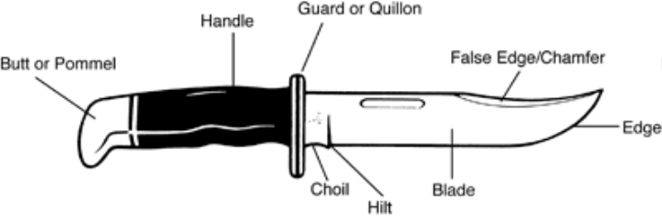
Knife Sharpening

Every knife needs sharpening from time to time. With the following instructions, you will be using the safest and most effective method of sharpening your knife. Never sharpen your knife on a power-driven grinding wheel. This can burn the temper from your blade, which will make the edge brittle and possibly chip or crack.

Knife Sharpening Equipment

For best results, use a sharpening stone. For quick touch-ups on a blade that is not too dull, use our fine grit diamond sharpening stone or our Arkansas Washita honing stone. For a more thorough sharpening on a blade that is dull, use the coarse grit stone first, then go to the fine grit stone or stones. Diamond sharpening stones may be used dry or wet, but wet is recommended. When using them wet, use water, not oil, as a lubricant. Washita stones should always be used wet. You may choose to use your stand-alone Washita stone (not attached to the Tri-Stone system) with honing oil as a lubricant. Once you do this, water will no longer work well as a lubricant and you will need to use kerosene or honing oil to keep your stone clean.

Types of sharpeners

► Diamond Stone Sharpeners
► A metal or composite base with an outer layer of micron-sized diamonds bonded to a metal surface. Many diamond sharpeners have special surface holes to prevent "filing build-up." Fast-acting and very effective. Use care to avoid excess pressure.
► Natural Stone Sharpeners
► Arkansas natural stones are genuine silica "Novaculite", indigenous to Arkansas. They come in different grits and have abrasive properties well suited for knife sharpening.

Types of sharpening fluid
Some people recommend sharpening dry and cleaning the sharpener as needed. Our recommendation is to sharpen wet because it keeps the pores of the sharpener clean, dissipates frictional heat and facilitates smooth sharpening action.
Diamond Sharpeners: Can be used wet or dry. If using a diamond sharpener wet, use water or water-based honing oil, not petroleum based oil.
Natural Sharpening Stones: Can be used wet or dry. Water, water-based honing oil or petroleum-based honing oil can be used. Be generous with the honing fluid. Use enough to keep a pool visible on the stone while you are sharpening. When the pool gets murky, pat or lightly wipe up with a rag and add more fluid.

Note: Once you use oil on a natural or aluminum oxide stone, it is difficult to change back to using water. Treat the decision to use oil as a permanent one. After every use, use a little extra fluid and wipe the sharpener clean and dry. Clean sharpening stone periodically to eliminate debris build-up (swarf). Glossy grey streaks indicate debris build-up. - If you sharpen with water or water-based honing oil, clean sharpening stone with soapy water. -If you sharpen with petroleum-based honing oil, clean sharpening stone with kerosene or more honing oil. Scrub with your finger or a mild brush, such as a used toothbrush

1
Practice sharpening on a non-valuable knife
Through the process of sharpening, scratches may occur beyond the edge of the blade. If you are new to sharpening, you may wish to practice on an old or inexpensive knife first to get the feel for avoiding unwanted scratches.

Sharpening straight blades (non-serrated)

Inspect your blade condition by holding the knife, edge up, and looking down the length of the blade— Look for nicks or flats spots reflected by light. Is the blade nicked or extremely dull? Start with Stage 1, Coarse Grit Stone. Is the blade somewhat dull or just needs a touch-up? Start with Stage 2 or Stage 3.

Stage 1: heavy sharpening—coarse grit sharpener

For extremely dull blades, inconsistent edge, or nicks/dull spots. This stage is the "rough cut" to remove inconsistencies in the blade edge and take it from very dull to sharp, but not finished. Buck's Diamond Sharpening Stone, Model 1327, has coarse 325 grit, suitable for stage 1 sharpening.

Sharpening fluid

► Diamond Sharpeners: Can be used dry or wet. If lubrication is desired, use water or water-based honing oil, not petroleum based oil.
► Natural Sharpening Stones: Can be used dry or wet. Water, water-based honing oil or petroleum-based honing oil can be used (see "Knife Sharpening Notes" for recommendations).

Hold the correct grind angle

Ideally, follow the grind and edge angle as they were when new. Scratches on the blade happen when sharpening. Use them to measure if you're angled too high or too flat against the stone, or if you're skipping off the edge of the stone

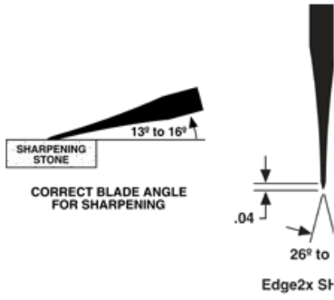
The angle on a Buck Knife is ground to 13-16 degrees per side (see illustrations). If you hold the knife against the stone to cut evenly across the edge grind, you will produce an edge with a similar angle. If you hold the blade at too high of an angle, the resulting edge will lose some slicing ability (but will stand up better to chopping). A good rule of thumb is to hold the blade so the back of it is about one blade width up from flat on the stone.

2
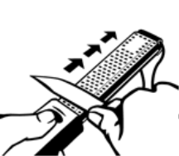
Maintain contact with the sharpener

Stroke the blade across the sharpener with even control. Too much pressure will crush or remove the grit from a diamond sharpener. It will also force a thicker burr on the edge, which is harder to remove or which can break off, creating new flat spots on the edge. Your stroke can be straight or circular, from "hilt to tip" –or- "tip to hilt," whichever is more comfortable. With most portable sharpeners, you need to stroke in a straight direction. The blade edge should face in the same direction as you stroke, so you move metal away from the edge. (Stroking toward the edge will create a thicker burr on the edge, the same as using too much pressure, with the same undesirable results).

When stroking the blade across the sharpener, as you work the length of the edge (from hilt to tip), do not let the tip of the blade skip off the edge, or end, of the sharpener. This results in a rounded tip or unwanted scratches on the side of the blade. Alternate blade sides. Do the same number of strokes on each side of the blade. If you do 15-20 strokes on one side, do 15-20 on the other side. Don't alternate sides with each stroke, or you won't get a burr. As you feel a burr developing on one side, switch to the other side and check that the burr is making the same progress on the other side.

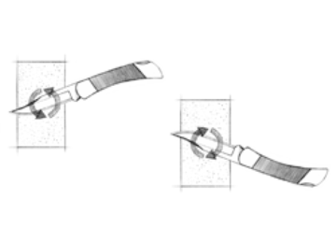
For circular sharpening, keep the blade on the surface and use an easy, clockwise motion with the edge facing right, until the desired sharpness is achieved. It is ideal to achieve the original factory edge.

Turn the blade over. Use an easy, counter-clockwise motion with the edge facing left. Try to spend the same amount of time on each side.

Work the "nicks" separately. If there is a nick on the edge, you can work just the area around the nick evenly, side-to-side. Once the nick appears to be gone, go back to working the entire length of the edge.

Inspect the "evenness" of your edge. The object is to have an even edge on both sides. Move to the next step when you feel the burr from hilt to tip on one side AND you see no nicks or dull spots along the edge. Pat or wipe your knife dry. Be careful—the burr can cut just like a sharpened edge. Move on to Stage 2 for working the edge.

Stage 2: medium or final sharpening—fine grit sharpenerFor typical dull blades - OR - continuing from Stage 1. This stage removes rough scratches or is an appropriate starting point for blades that are somewhat, but not overly, dull. Buck's Diamond Sharpening Stone, Model 1328, has fine 750 grit, suitable for Stage 2.
Sharpening fluid

► Diamond sharpeners: Can be used dry or wet. If lubrication is desired, use water or water-based honing oil, not petroleum based oil.
► Natural Sharpening Stones: Can be used dry or wet. Water, water-based honing oil or petroleum-based honing oil can be used (see "Knife Sharpening Notes" for recommendations).

Sharpen the edge, following the same steps as in Stage 1. You can achieve a good, sharp edge and finish at this stage without going on to Stage 3. To do so, hone with light, single strokes, side-to-side, until you feel no burr on either side. To fine-tune the edge or smooth "sharpening scratches", skip this step, go to Stage 3.

Stage 3: fine sharpening—natural stone
3
For slightly dull blades - OR - continuing from step 2. This step removes any remaining burr and puts a burnish on the blade edge. Buck's "Arkansas Washita Honing Stone" has fine 600 grit that is suitable for Stage 3.

Sharpening fluid

► Natural sharpening stones can be used dry or wet, but wet is recommended. Water, water-based honing oil or petroleum-based honing oil keeps the pores of the stone clean, dissipates frictional heat and ensures smooth sharpening action. Once you use oil on a natural or aluminum oxide stone, it is difficult to change back to using water. Treat the decision to use oil as a permanent one.
► Be generous with the honing fluid. Use enough to keep a pool visible on the stone while you are sharpening. When the pool gets murky, pat or lightly wipe up with a rag and add more fluid.

Use the same stroking motion as described in Stage 1. Repeat until scratches from the previous grit stone are gone. You should still feel a burr, but it should be smaller/finer. Once you clean all the scratches off the edge from the previous grit, use light, single strokes side-to-side. Make one stroke from hilt to tip, then turn the knife to the other side and stroke once from hilt to tip. Repeat this several times until you can't feel any burr on either side of the edge, from hilt to tip. The knife should be razor sharp at this point. If the knife fails to cut as expected, you may need to start again from Stage two. Remember, if you use too much pressure against the stone, you will raise a thick burr instead of removing it.

Sharpening Serrated Blades

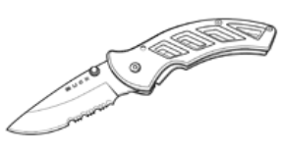
Sharpening serrated blades and gut hooks requires a different technique and different style sharpener. Do not use a flat sharpening stone. Buck's Diamond Taper Sharpener or Diamond Pocket Sharpener is the right tool for this job. Even a taper sharpener cannot create the same kind of edge that was originally on the knife. This makes it difficult to achieve better than a "serviceable" edge on these features, and that should be your objective—not achieving perfection. Because of their shapes, these features are more easily distorted through sharpening than a blade edge. You may wish to consider sharpening serrations and gut hooks only when dull spots are visible

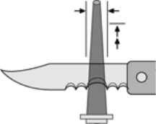
Serrations have a grind on one side of the blade only. Sharpen the grind side only. Hold the sharpener at the angle that matches the original edge angle. Put the pointed, narrow end of the sharpener up against the serration and stroke the sharpener into the serration—away from the edge of the blade, toward the spine. Stop stroking when the width of the taper sharpener gets to the same width as the serration (do not enlarge the width of the serration). Rotate (spin) the sharpener as you go for even, consistent sharpening. Check progress and continue until you feel a very slight burr.

4

