**EASY HACKS**

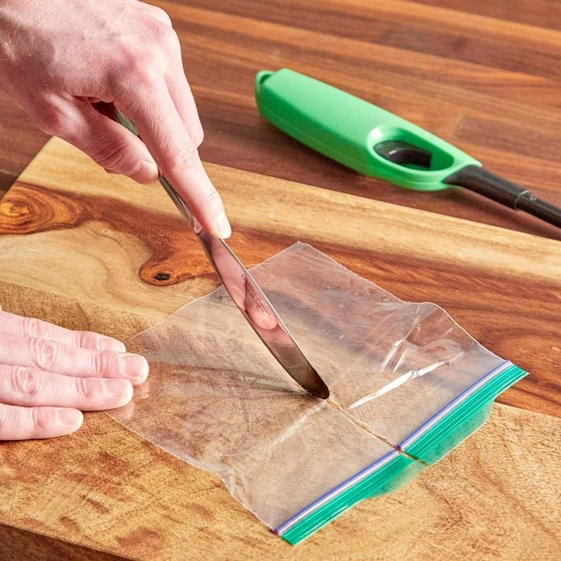**How to Double Your Resealable Bags**

This might be the coolest way to turn sandwich-size bags into snack-size bags! Here’s how to do it:

Heat up an old butter knife with a lighter and slice the bag in half. The hot knife cauterizes the edges of the two new bags. The cauterized edges are as strong as the factory sealed edges! – Julia Trenton

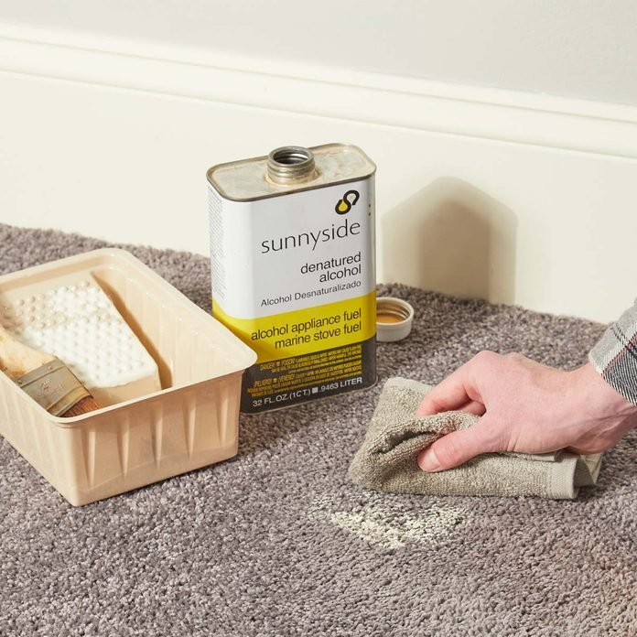

**Clean Up Paint in Carpet**

I used to think dropping a loaded paintbrush on the carpet meant replacing the carpet, until a former foreman told me this little tip. Pour some denatured alcohol onto a rag and scrub away the paint. Use a rag that is as close in color to the carpet, as the alcohol can transfer some of the rag’s color to the carpet. – Tom Gerdowsky

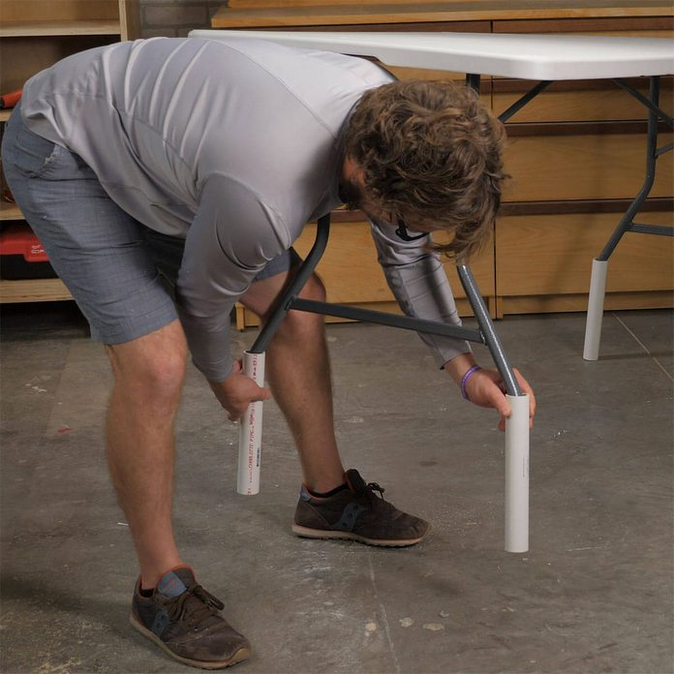

**Taller Table Hack**

I have a typical 6-ft. folding table that I use to layout certain projects. But the height of the table is meant for someone sitting in a chair. Constantly bending over when using the table was starting to hurt my back, so I came up with a solution. I used a couple of 2-ft. lengths of 1-1/4-in. PVC pipe found at my local home center, and cut four 11-in. stilts for my table.

I slipped the pipes onto the legs and it raised the table about 6 in., bringing my work surface to a more comfortable height! The bend in the table legs at about 5 in. from the ground holds the pipes securely in place, so my table is still as sturdy as ever. The stilts can be removed if I ever need to lower the height of the table to use it while sitting in a chair. — **Gary Inlow**