**TRUE EXPRESSED LOVE**

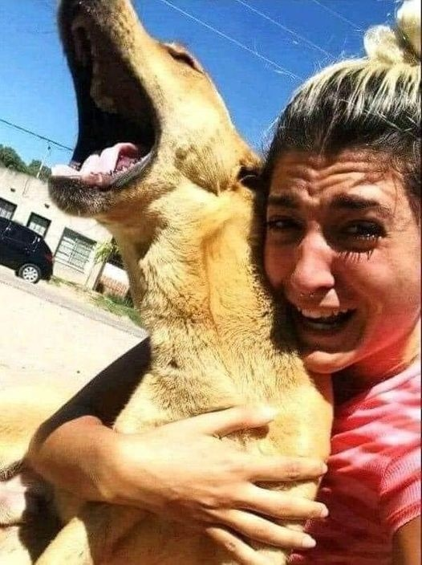

The dog was stolen from this woman, she gave up her job to be able to search for him intensively. Three months later, she found him at the other end of the country. Here’s the moment of happiness when they finally saw each other again ♥️